1. Let’s understand how image and container together works.
2. 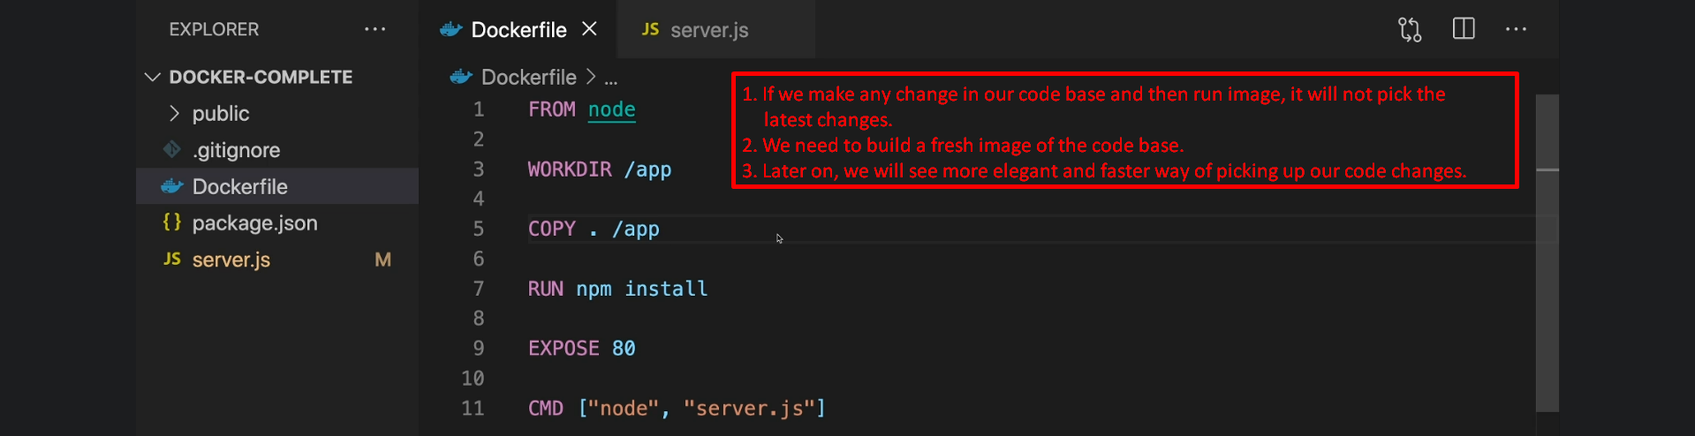
3. Images are locked and finished once they are built. We can’t edit from outside. We can’t make any changes to an image. They are read-only.
4. 